INTERNATIONAL LAUNCH EVENT FOR IPCC AR5

IPCC 5th Assessment, Working Group II, Polar Regions Chapter

Arctic Indigenous Peoples,
Managing Change?

Guovdageaidnu/ Kautokeino, Norway - March 31st, 2014

Lunch Served from 11:30

12:30 THE PROGRAM STARTS

Short Video: Reindeer Husbandry and Climate Change
Event Moderators: TBC

12:35 OPENING SESSION

Welcome Address
President Aile Javo, Saami Council
Executive Chair Dr Mikhail Pogodaev, Assoc. of World Reindeer Herders

Greetings
Mr Achim Steiner, Executive Director of UNEP and Under-Secretary-General of UN
(written personal greeting).
Prof. Chris Field, Stanford University, Carnegie Institution for Science, USA (Video)
Co-Lead of IPCC AR5 WG 2
University of the Arctic, President Lars Kullerud
Dmitry Marfusalov, Mayor of Khatystyr, Aldan Ulus, Sakha Republic
Anatoly Lebedev, Association of Evenki of Southern Yakutia, Oron - Union of Obschinas, S.Y.
Battulga Solnoi, Taiga Nature Society, Tsaganuur, Mongolia TBC

Keynote
The Science of Climate Change
Robert W Corell, Science and Technology Foundation, Professor, UArctic EALÁT Institute at ICR
13:30 INTRODUCTION – IPCC AR5 WG II

General Overview of IPCC AR5; The IPCC AR5 WG II Polar Regions Chapter
Dr Nancy G Maynard, NASA and University of Miami, USA.
Polar Regions Chapter Lead Author (LA)

Real Impacts for Arctic Indigenous Peoples: Illusions of Adaptation or Resilience?
Dir. Anders Oskal, International Centre for Reindeer Husbandry (ICR)
Polar Regions Chapter Co-Author (CA)

Arctic Climate Change and Human Security
Dr Grete Hovelsrud, Nordland Research Institute, Cicero (by Skype, TBC)
Human Security Chapter Lead Author (LA)

Short coffee break (20 min)

14:30 ARCTIC CLIMATE CHANGE AND INDIGENOUS SOCIETIES

Sámi Youth Perspectives – Does It Really Matter?
Anne Márja Magga, Finnish Sámi Youth NGO

Russian Indigenous Youth Perspectives – Change and Education
Nechei Serotetto & Kseniia Tibichi, Nenets reindeer herders from Yamalo-Nenets AO, Russia, and Students at the Institute of Indigenous Peoples, Herzen University, St.Petersburg

Russian Indigenous Peoples´ Perspectives
Olga Iavtysaia, Nenets reindeer herder from Nenets AO, Russia
Alexander Pogodaev, Even reindeer herder from Sakha Rep., Russia

Greenlandic/ Inuit Perspectives
Lene Holm, Greenland Climate Research Centre, Greenland

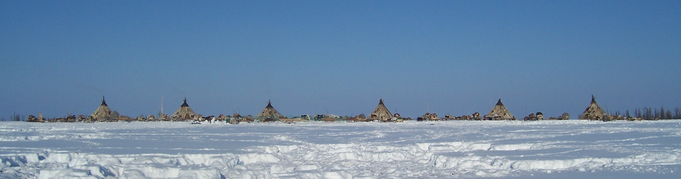
15:20 CLIMATE CHANGE RESILIENCE – MANAGING CHANGE:
Research, Education, Local Business & Food Culture

Science and Traditional Knowledge Co-Production
Lene Holm, Greenland

Contribution to Knowledge Production: Arctic Indigenous Researchers´ Association
Ellen Inga Turi & Anna Degteva

Education and Two Ways of Knowing: Learning by Herding
Inger Marie G Eira, Dr, Vice-Rector, Sámi University College, Norway

Education in a Cross-border Sámi Context
Ellen Inga O Heatta, Rector, Sámi Upper Secondary and Reindeer Herding School

Arctic Council EALLIN Reindeer Herding Youth – Engagement of Young Herders
Alena Gerasimova & Ravdna BM Eira

Arctic Indigenous Peoples´ Culinary Institute – A New Approach to Manage Change
Anders Oskal, Dir. International Centre for Reindeer Husbandry (ICR)

Thon Hotels´ Vision for the Arctic and Local Sámi Food Culture - Biebmu
Morten Thorvaldsen, CEO Thon Hotels, Norway TBC

16.30 MEDIA PANEL DEBATE – ´ARCTIC LAVVU DIALOGUE´

A “lavvu” is the indigenous Sámi term for the traditional
nomadic tent, the natural dwelling place for discussions around the
fire for Sámi people and herders. The dialogue will take place in a virtual lavvu.

Dialogue Theme:
“Is Adaptation Possible, Will Democracy Cope? Managing Knowledge, Resilience and Power”

Dialogue Moderators:
Ms Gunn Britt Retter & Dr Robert Corell

Arctic Lavvu Dialogue Participants - TBC
Integrated media/ public Q & A with Dialogue Participants

16.45 FINAL REMARKS, SUMMING UP

The event will have simultaneous interpretation into Russian, English and Sámi
The event will be streamed live at www.arcticportal.org and www.reindeerportal.org.

18.00 (ca) DEPARTURE FOR A MEDIA FIELD TRIP TO A REINDEER HERDERS´ CAMP

